Marc Blain 15349941 Programming Paradigms Assignment 2-Racket

<https://github.com/MarcBlain/ct331_assignment2>

Part 1:

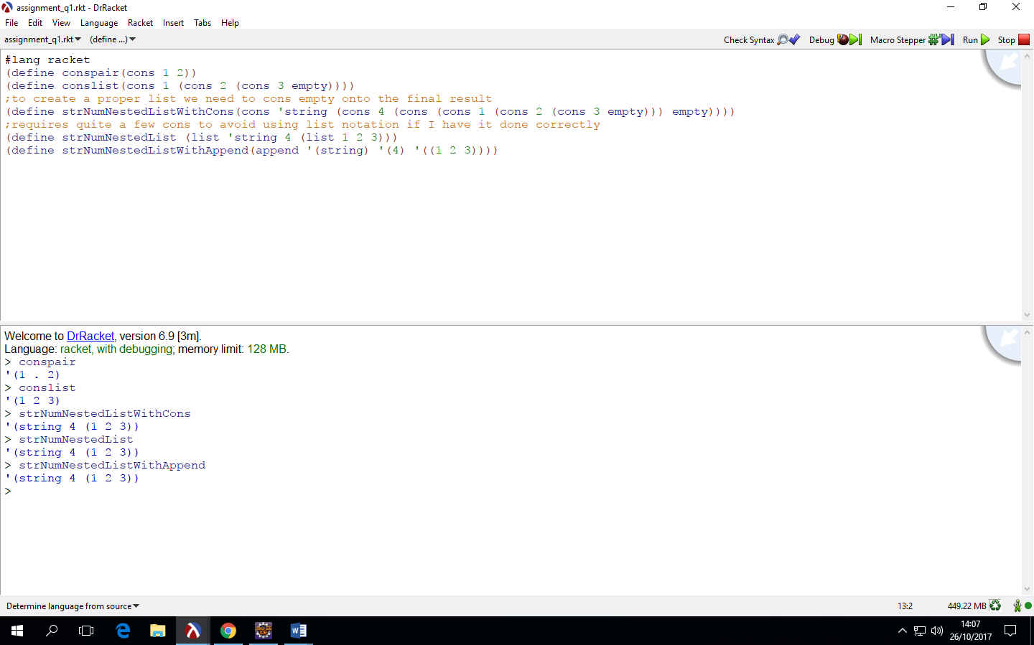

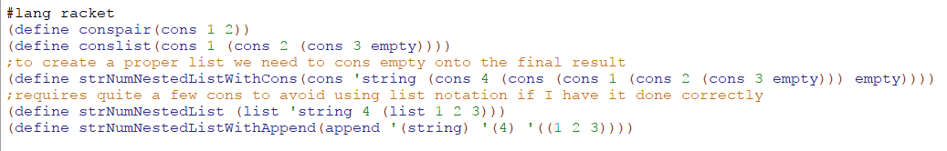

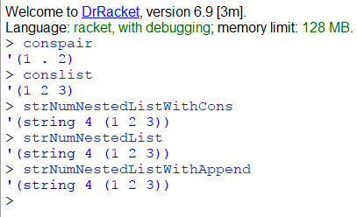

Cons takes two s expressions and forms a single s expression. The list function takes a series of zero or more s-expressions and combines them into a list, which is shown in the command line output as a single unit, but is really a shorthand for a more complex s-expression (a nested series of pairs, with the second item of the innermost pair being the empty value) While the cons function always takes two values, both list and append can take any number of values. The append function builds a list, but each of its arguments must also be a list, and in contrast to the list function, each argument list is chained onto the previous, which makes one long list of all those elements.

Part 2:

Part 1

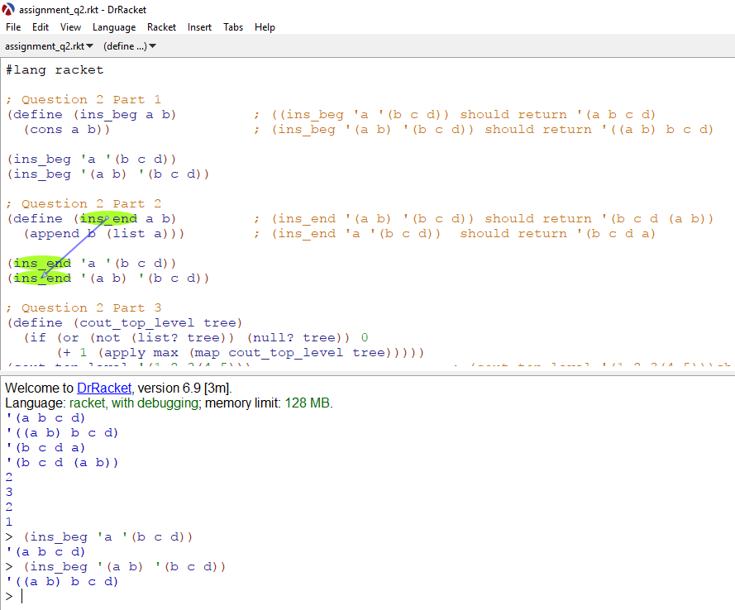

Part 2

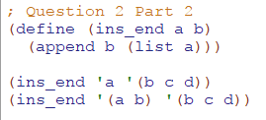

Answer:

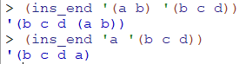

Part 3:

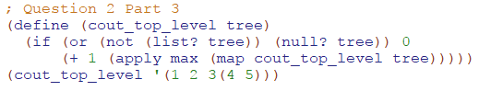

Answer



Part 4:

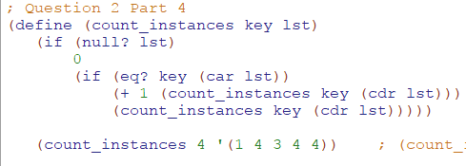

Answer



Part 5:

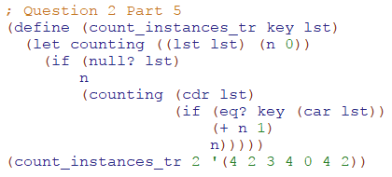

Answer



Part 6

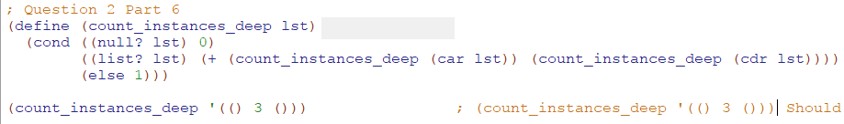

Answer



Part 3:

Tree



Part A

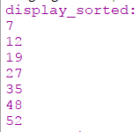

Part B



Part C&D



Part E

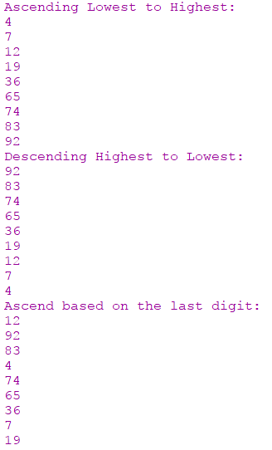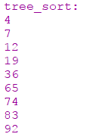

Part F ------_ >